**Mark: _______ / 30**

**HARRISDALE SENIOR HIGH SCHOOL**

SCIENCE DEPARTMENT

Earth and Space Sciences Investigation

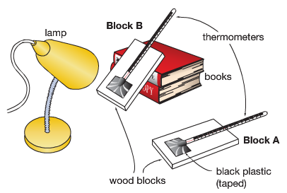**Time allowed:** 1 period to plan investigation, 1 period to conduct investigation, 1 period to complete interpretation and evaluation of results.

**Task:** In groups you will use a model to test whether the angle of sunlight affects the surface temperature on Earth.

You will use black paper stuck to a piece of cardboard to simulate the surface of the Earth. Cardboard A will be laid flat under the heat source, and cardboard B will be propped up on textbooks so it is at an angle. You will measure the temperature of each piece of cardboard every minute for 15 minutes.

**Investigation Title** [1 mark]

**Aim**  [1 Mark]

What are you trying to find out in the investigation?

**Variables** [4 Marks]

|  |  |  |
| --- | --- | --- |
| Independent Variable  (Changed) | Dependent Variable  (Measured) | Controlled Variables  (Kept the same) |
|  |  |  |

**Hypothesis** [1 mark]

A testable statement, linking the independent and dependent variables.

**Materials** [2 Marks]

List the materials needed to conduct the investigation.

**Method** [3 Marks]

A numbered list of steps describing how to conduct the investigation.

**Results Table** [2 marks]

In the space below construct a table to record your results.

**Results Graph** [6 marks]

On graph paper, draw a scatter graph of your results by hand. Include lines of best fit for each piece of cardboard in your investigation and a key.

Hand your graph in to your teacher, or take a photo of your graph and insert it into the word document.

**Interpreting and Evaluating**

1. Use your results to explain how the angle of sunlight affects the temperature. [2 marks]
2. Which piece of cardboard represents the Earth in summer and which represents Earth in winter? Explain your choice. [4 marks]
3. Describe one inaccuracy in the investigation that may have caused unfair results and propose a possible solution. [2 marks]
4. Use your results to explain why hot, tropical climates are found near the equator, and cold, icy climates are found near the poles.[2 Marks]